**Vehicle Showroom and Service Management System**

**Abstract:**

The vehicle showroom and service management software Application is a Web-based Application which helps to manage the vehicle showroom & service center activities seamlessly. In current Scenario small scale showroom’s uses a excel to keep track of vehicles in showroom. And also, service centers have no provision for any-tracking and no full proof solution to integrate same. In conventional method there are lot of human errors or also some cumulative errors. So, to avoid them we give full proof solution for showroom and service center management (small scale). This application will also provide online service and vehicle booking facility.

In this software there are no. of provisions like to maintain employee data, maintain customer data, maintain transaction details & also maintains vehicle details which we can use as per our requirement for future use. Software provides security and data integrity features along with proper channel of authorization via Admin login which avoids frauds or loss due to miscommunication in conventional system.

**The below are the modules available in the proposed system:**

1. Customer Registration.
2. Customer login.
3. Employee Login.
4. Admin Login.
5. Vehicle List Display to all.
6. Edit Vehicle data from list by Admin.
7. Book Vehicle directly by Customer through online mode or by Sales manager for customer who directly comes to Showroom.
8. Book Service by Customer through online mode.
9. Invoice Creation by Employee.
10. Add Service for Customer.
11. Payment page

**Admin:**

Admin will have a unique URL to access the whole contents of website. Admin needs to get logged in by entering valid credentials. Admin can view all the details of the registered Customer and can Add and Delete Customer from the Database. Admin can add Employee to Showroom also can remove an employee from the Showroom. Admin can view all the vehicles available in the showroom and the list of Booked vehicles. Admin can view all serviced vehicles data. Also, admin can edit the data of serviced vehicles.

**Employee:**

There will be Two categories of Employee –

1. Sales Manager.
2. Service Manager.

Sales Manager will be handling all the work related to Vehicle purchase. Sales manager can register a customer who directly comes to the showroom for first time. He can also book a vehicle on for customer. After completion of the vehicle purchase sales manager will have to mark vehicle as purchased and create required documents for the vehicle with invoice and hand it over to the customer. Also, Sales manager can view all the vehicles data from the showroom.

Service Manager will be handling all the work related to vehicle service. Service manager will add customer who directly comes to the showroom for vehicle servicing for first time. Also, sales manager will accept payment and create invoice for the customer who comes directly to the showroom.

**Customer:**

Customer can register to the website and login to the same. Customer can see the list of vehicles that are in the showroom. Customer can book a vehicle online by making the minimum required payment for the vehicle and will receive the invoice of that payment details. To purchase vehicle customer, have to go to showroom and make full payment to the sales manager so that sales manager will prepare all the documents of vehicle and hand it over to the customer. Customers can also come directly to the showroom, in this case all the registration process and booking of vehicle will be done by sales manager. Customer can also book vehicle servicing slot on the website after registration. They can make a payment of the servicing through payment gateway and after payment they will receive an invoice. Customer who comes directly to the showroom for vehicle servicing service manager will do all the registration process for the customer. Also, service manager will create invoice for the servicing.

**Requirements:**

**Software Requirements:**

1. JDK: JDK 11.

2. Backend: SPRING MVC/SPRING BOOT.

3. Frontend: Html, CSS, Bootstrap, java script, jQuery.

4. Programming Languages: JAVA, J2EE.

5. Database: MySQL5.

6. IDE/Workbench: STS.

**Hardware Requirements:**

1. Operating System: Windows 10 (32/64).

2. RAM: 2GB (Minimum) / 4GB (Recommended).

3. Memory: 500GB.

***Vehicle Showroom and Service Management System***

**USECASE DIAGRAM**

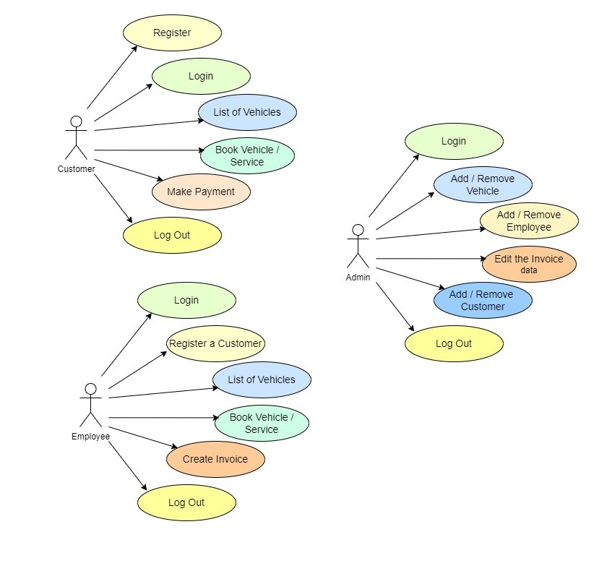

**DATAFLOW DIAGRAM**

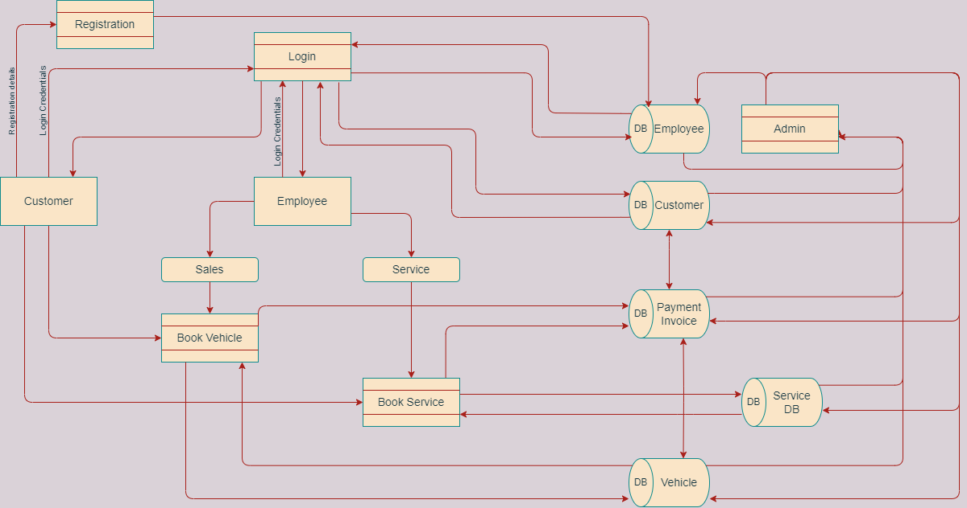

**CLASS DIAGRAM**

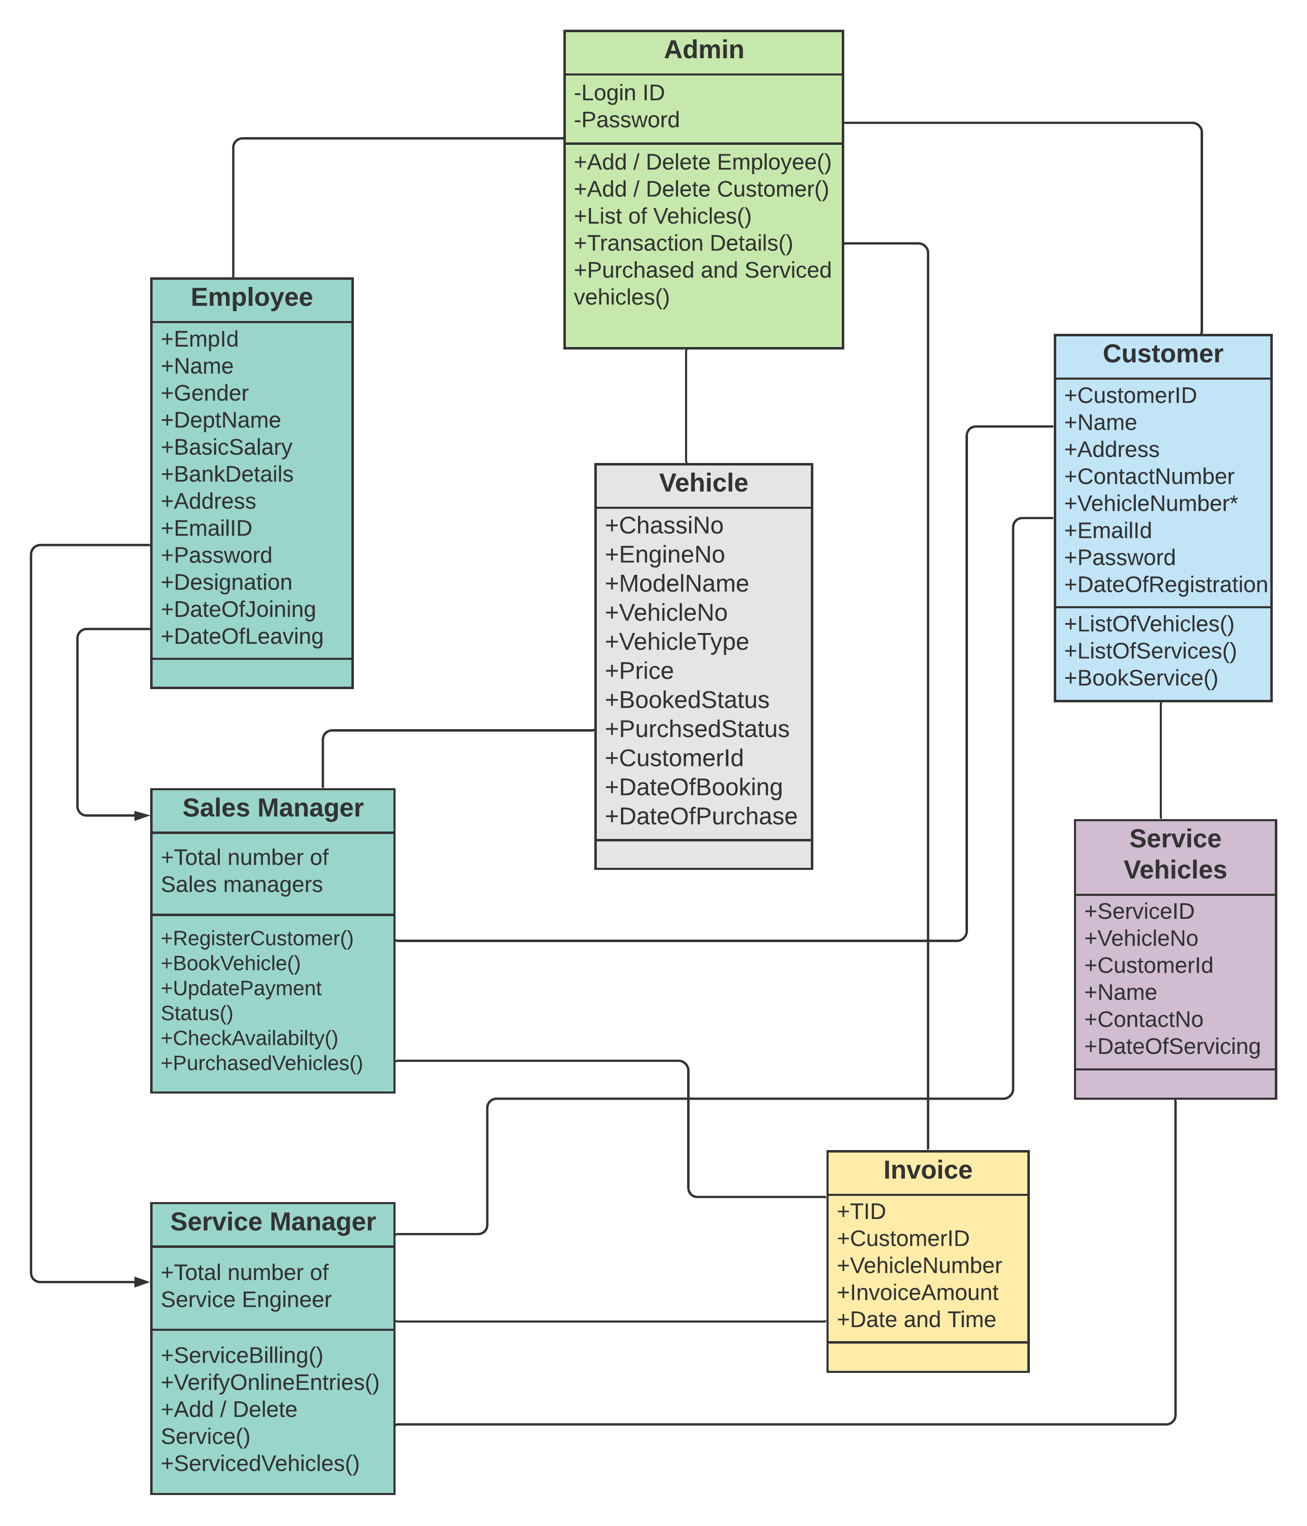

**ACTIVITY SEQUENCE**

1. 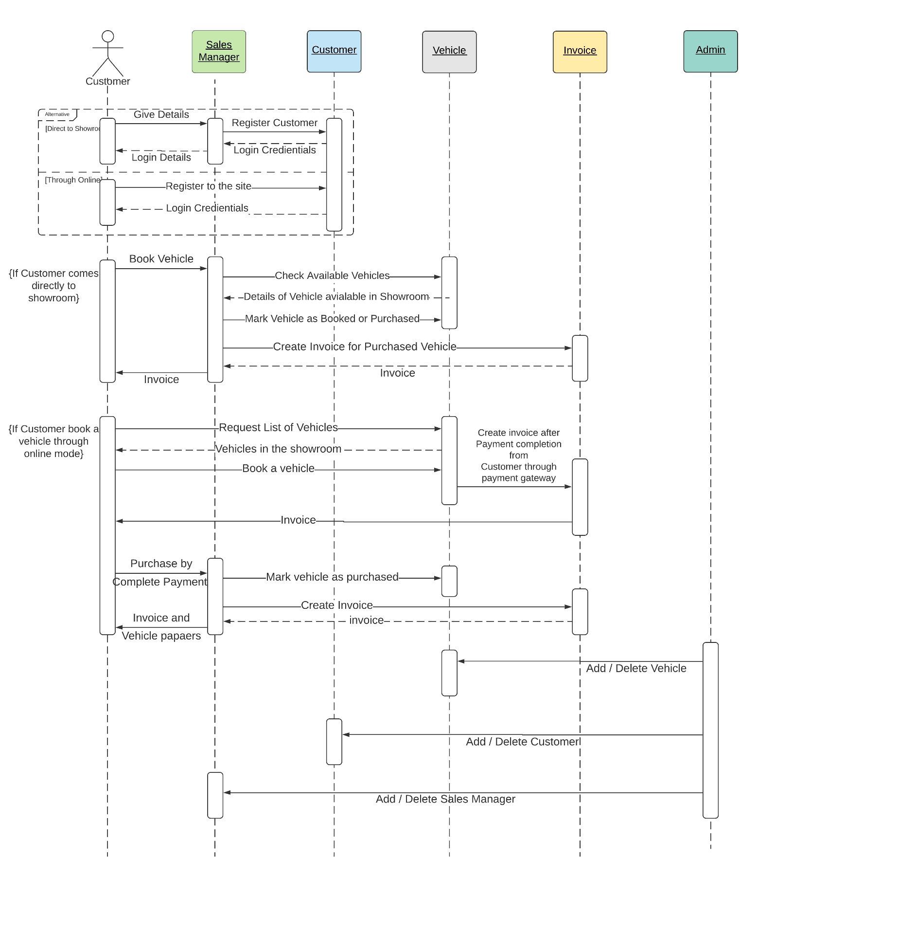**To Purchase a Vehicle**
2. **To Book a Service**

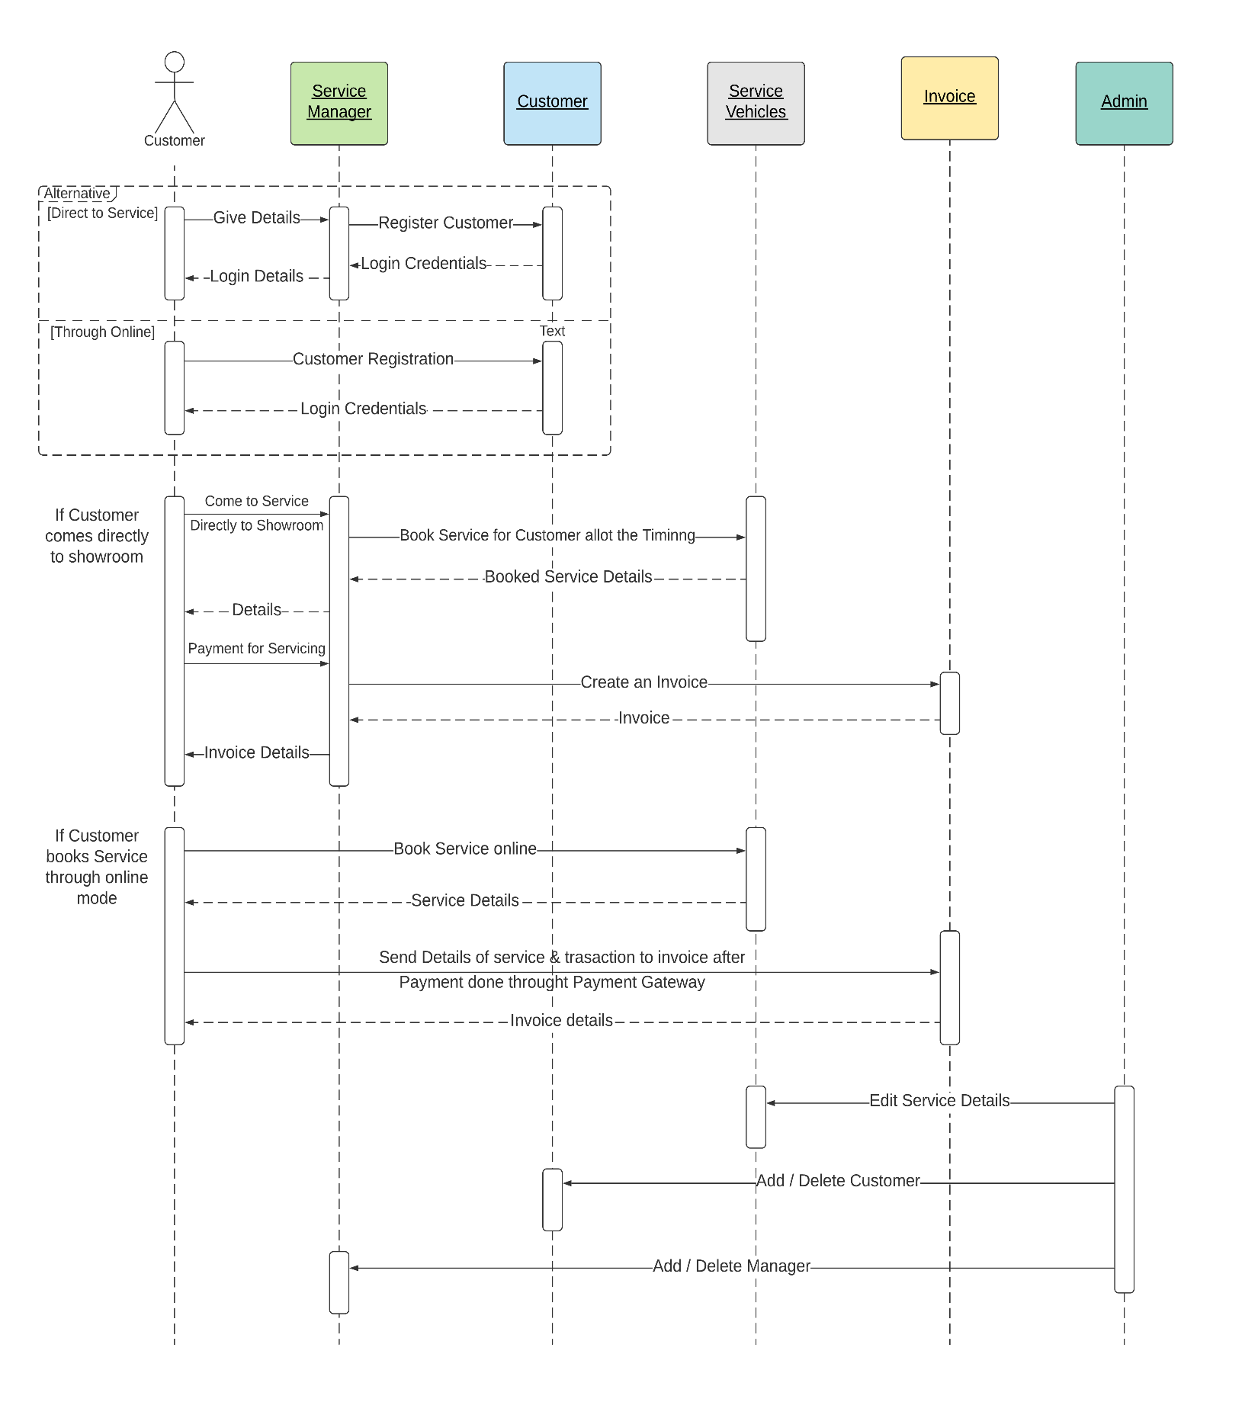

**ENTITY RELATIONSHIP DIAGRAM**

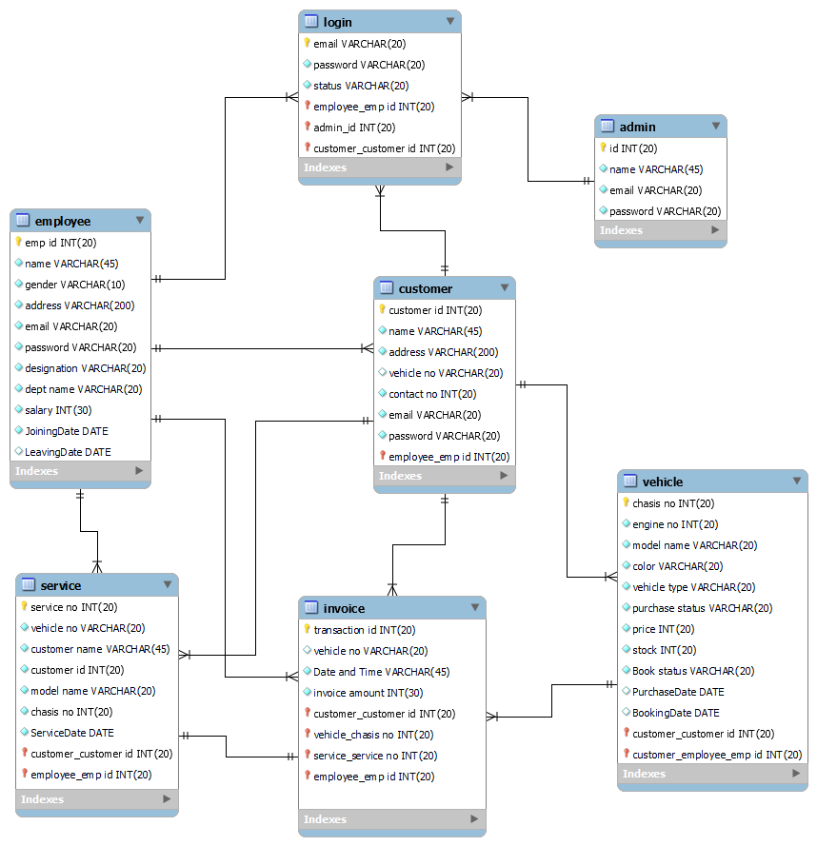

**DATABASE DIAGRAM**

